**Power**

Powershare.c

#include<stdio.h>

int power(int b, int e)

{

if(e==0)

{

return 1;

}

else

{

return b*power(b,e-1);

}

}

Powershare.h

#include<stdio.h>

#include"powershare.c"

extern int power(int b, int e);

Powermain.c

#include<stdio.h>

#include “powershare.h”

int main(){

int b,e,ans;

printf("Enter the base\n");

scanf("%d",&b);

printf("Enter the exponent\n");

scanf("%d",&e);

ans=power(b,e);

printf("Result is %d",ans);

return 1;

}

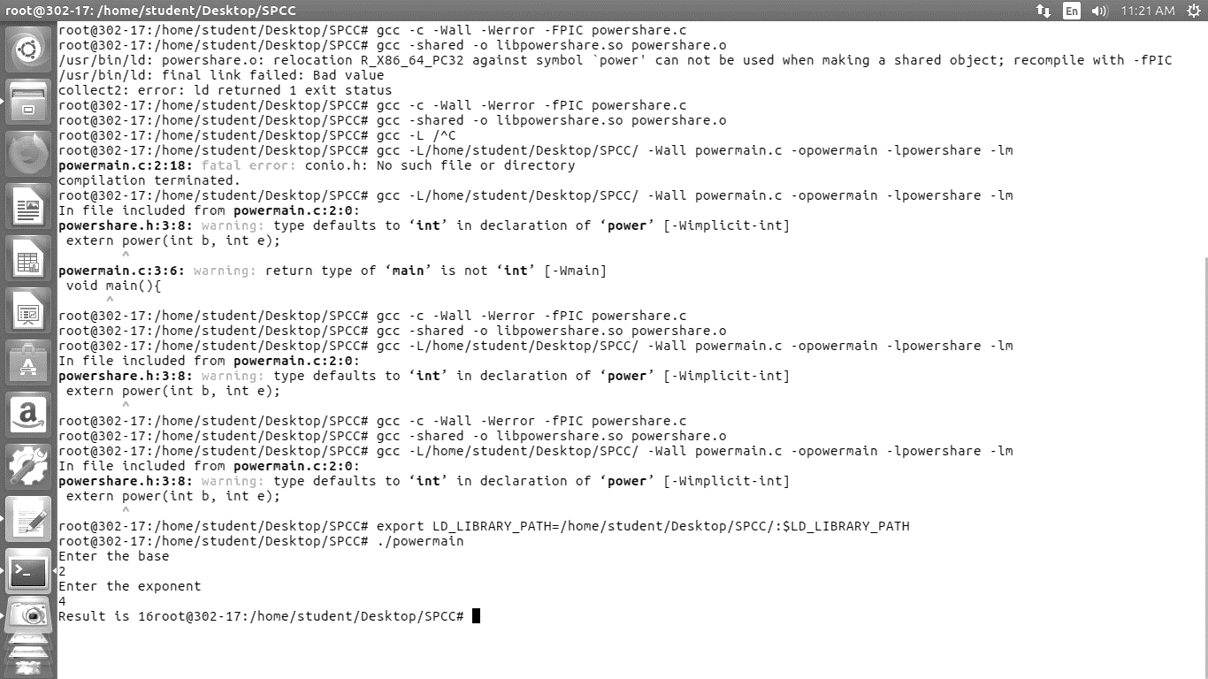

**Exponent**

Factshare.c

#include<stdio.h>

int factorial(int n)

{

if(n == 1 || n == 0)

{

return 1;

}

else

{

return n*factorial(n-1);

}

}

Factshare.h

#include<stdio.h>

#include"factshare.c"

extern int factorial(int n);

Factmain.c

#include<stdio.h>

#include"factshare.h"

int main()

{

int n, res;

printf("Enter the number: ");

scanf("%d",&n);

res = factorial(n);

printf("The factorial of %d is %d\n",n,res);

}

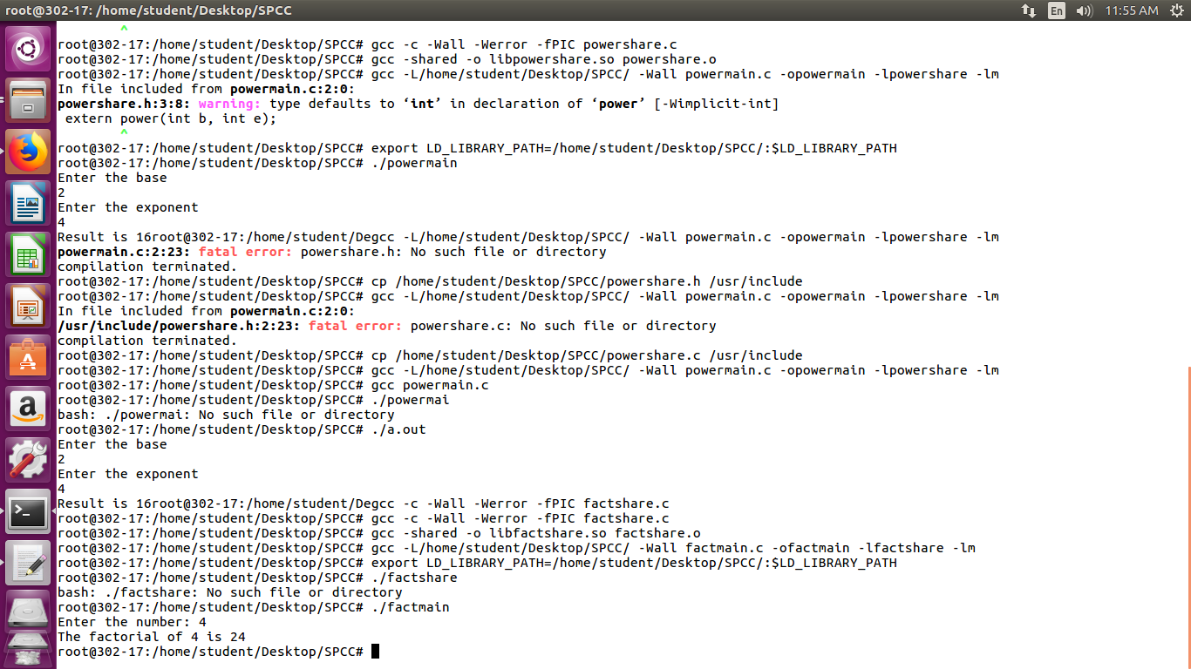

**Square Root**

rootshare.c



rootshare.h

rootmain.c



